Move Tank Block

# Basics

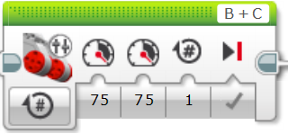

Left Motor Port

Right Motor Port

Left

Motor

Power

Right

Motor

Power

Brake when finished

Number of Rotations/Degrees/ Seconds

MENU

# Move Tank – Menu

## Off

This block is used to stop or brake the motors.

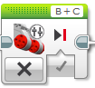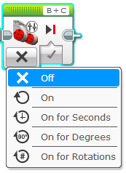

## Brake Options

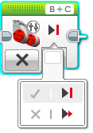

Turn Motor Off and Brake Motor

Turn Motor Off and Coast, No Brakes

# Move Tank – Menu

## On

This block should only be used inside a loop.

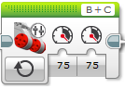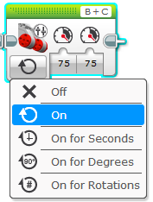

## Power Option

Use either option.

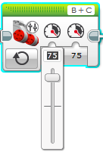

Type your Power.

Drag to select your Power.

# Move Tank – Menu

## On for Rotations

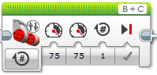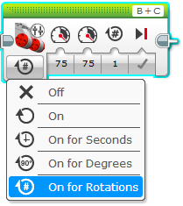

## Rotations Options

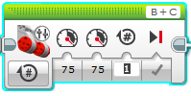

Type your Rotations

Same as before

Same as before

# Move Tank – Menu

## On for Seconds

Move your robot for a specific amount of time.

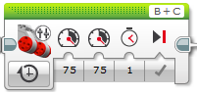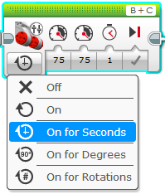

## Time Options

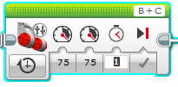

Type your Time

Same as before

Same as before

# Move Tank – Menu

## On for Degrees

Used for small movements. Turns the motor an exact degree.

1 Rotation is 360 Degrees.

$\frac{1}{2}$ Rotation is 180 Degrees.

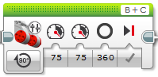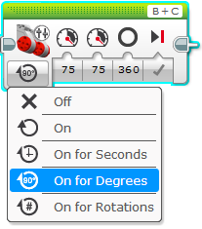

## Degrees Option

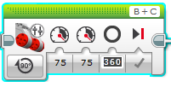

Same as before

Same as before

Type your Degrees